**Errors In Pipeline**

1. Access denied error while executing pipelines

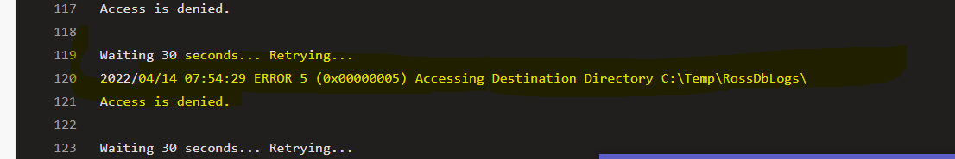

**Solution:-**

* Login to agent installed VM,
* Open power shell cmd through run as admin account.
* Up the agent.